**PHASE 1 - GUILLOTINE CUTTING PROBLEM**

**PHASE 2 - CORRUGATOR BULLETIN SEQUENCING**

Corrugator part 1

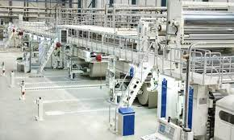

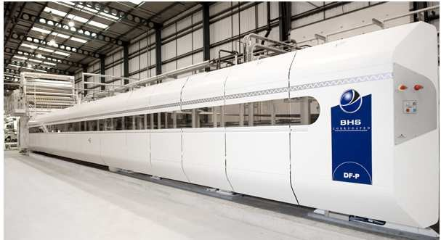 **Corrugator part 2**

**Corrugator part 3**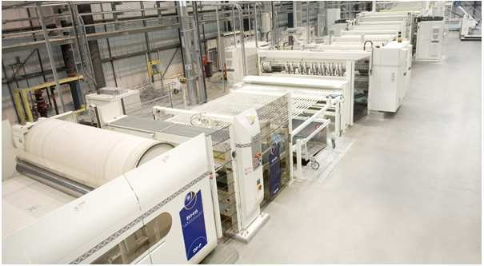

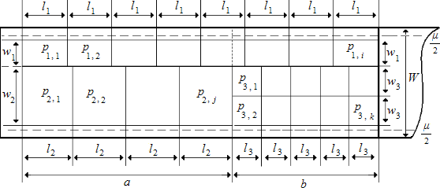 Cardboard sheet figure with cut design – 3 orders in 2 combinations

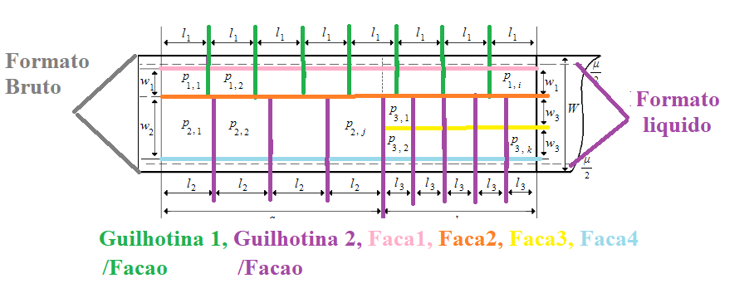

3 conjugations for 3 requests

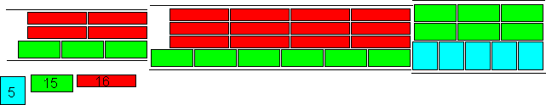

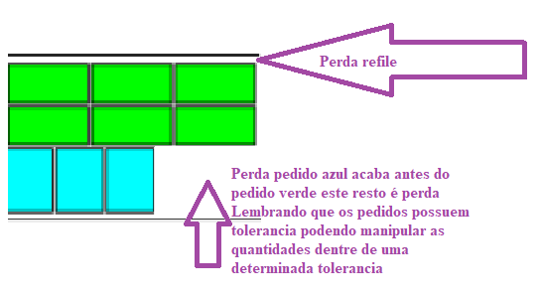

Restrictions addressed in the current version of the algorithm and valid for the first exercise

Objective function: production of all orders while minimizing losses.

Variaveis   
FormatoBruto = 2460  
FormatoLiquido = 2430  
RefileMaximo =180;  
FormatoLiquido = FormatoBruto - RefileMaximo;  
FormatoLiquido = 2280;  
MLinearMinimo = 300  
MultOP1 = numero de chapas na largura pedido 1   
MultOP2 = numero de chapas na largura pedido 2

Restrições   
GUILHOTINAS/Facao <=2 // numero de guilhotinas/fações   
(_MultOP1+_MultOP2)+1 <=8// RESTRIÇÃO DE CORTES horizontais na largura da chapa  
((LARGURA_PECA * _MultOP1) + (LARGURA_PECA * _MultOP2) <= FormatoLiquido ) // tamanho macima da banda da onduladeira pendencia tratar chapa da largura bruta  
((LARGURA_PECA * _MultOP1) + (LARGURA_PECA * _MultOP2) >= FormatoMinimo ) // tamanho minimo da banda da onduladeira  
((COMPRIMENTO_PECA * QtdChapas) / _MultOP1)>= MLinearMinimo // metragem linear maior igual que a restrição de metragem minima do pedido 1  
((COMPRIMENTO_PECA * QtdChapas) / _MultOP2)>= MLinearMinimo // metragem linear maior igual que a restrição de metragem minima do pedido 2

**Other information about the problem**:

- A corrugator can work with several cuts across the width of the sheet, in our client's case it goes from 0 to 8 at the same time – with 8 knives.

- In terms of length, most corrugators work with 2 blades/guillotines. This means that they can make 2 different cuts at the same time. It is rare to find corrugators that have 3 blades and can make 3 cuts at the same time. In our client's case, there are 2 blades. Each blade cut produces 1 or more sheets, depending on the number of cuts in width directed by that blade.

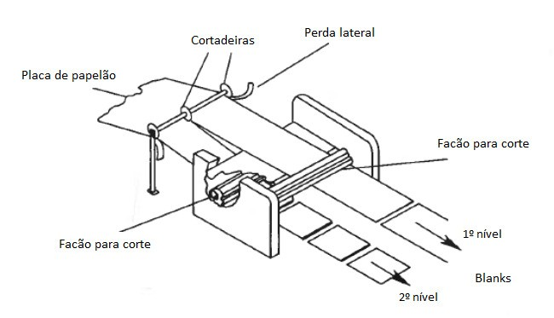

Cutters = knives

Blanks = sheets

- Maximum length of the upper blade = 4350mm. Maximum length of the lower blade = 2900mm. Minimum length of the sheet = 600mm.

- The main objective is to maximize the use of the width of the corrugator – or minimize the total loss. Corrugators vary in width, our client's has a gross width of 2460mm and a net width of 2430. Our restriction is based on the net width, except in cases where the sheet is the same size as the gross width.

- There is a mandatory lateral loss of 30mm (15mm on each side) for finishing the cardboard sheet. There are some exceptional cases in which this lateral loss does not occur because the dimensions of the sheet occupy 100% of the width – but these are few cases.

- Our client's corrugator supports up to 180mm of maximum loss. A loss greater than 180mm causes clogging of the equipment that collects this loss. In other words, it cannot be programmed with a loss greater than 180mm. - As a business rule, the client's PPC has the autonomy to program the corrugator with up to 140 mm of lateral loss - already including the loss of 30 mm of finishing. Above this and up to 180 mm, it needs to go through a higher approval.

- Orders are grouped according to the thickness of the wave and the weight of the paper used to form the cardboard sheet. This forms a composition. The company works with “n” different compositions.

- Once grouped by composition, it is necessary to put together a bulletin. A bulletin is made up of “n” orders (they can be few, like 5 or 6, or they can be many, with 50, 60 or more orders). These orders are organized in combinations. A combination is made up of 1 or 2 orders being produced at the same time.

- The client's PPC has the autonomy to create a bulletin with orders with a delivery date up to 7 days in the future so that it can create good combinations. It is possible to search for orders that are further away with higher approval.

- In a bulletin, all orders are of the same composition, but each order has different lengths and widths – according to the product design. In addition, the quantities of sheets that need to be produced also differ for each order. This means that an order can participate in 1 or more different combinations within the same bulletin. Order A can be combined with order B and then with C – according to the characteristics of each project (width and length of the sheet) and the quantity of sheets that need to be produced.

- Here, there is also a loss to be minimized. At the end of the combination, the best scenario is for the 2 combined orders to end together or with the smallest possible difference in total linear footage. Therefore, we seek a linear footage close to balance between the 2 combined orders whenever possible. There are production tolerances for more and less that can be used to balance orders

- Each combination must have at least 300 linear meters – business rule. Otherwise, the corrugator loses speed. The linear footage is calculated considering the length of each sheet, the number of sheets that will be produced and the number of width cuts used in the combination. There are cases of small orders that do not reach this minimum, a situation that is already calculated in advance so that the loss is commercially compensated. In such cases, the business rule can be broken.

- When it is not possible to assemble combinations that meet the business rules, the aim is to change the composition of the cardboard of an order to combine with another and offer a viable combination. This change in composition can occur in several ways: producing the order using a superior composition, applying resin to a product originally without resin, changing the type of wave, changing the type of paper. When this occurs, one of the orders will need to receive what they call a promotion, that is, be produced with a composition above its requirements. Everything is validated with the commercial area.